Head of Strategic Asset Management
Service: |  | Property | Grade: |  |  |  | Salary:
Reporting to: |  | Assistant Director Property | Location: | Salford Civic Centre |  |  | Hours: |  |  |  | 36
About the role |  |  |  |  |  |  |  |  |  | Our priorities
- The Head of Service for the Strategic Asset management team will produce , manage and drive the Strategic management of the City Councils property portfolio. The role will include overseeing the delivery of all transactional matters associated with the management of the City Councils property portfolio  - The Head of Service will provide strong leadership, clear direction and support to the team and instil integrity coupled with an entrepreneurial spirit to deliver required outcomes  - Lead, inspire and provide senior management support to employees within the team, motivating and supporting them to attain the highest professional standards, skills, knowledge, attributes and competencies required to fulfil their duties and work programmes  - Take a lead role in the wider Strategic management of the Council's property interests and portfolio within Salford (Through the Local Asset Review and work of the Strategic Estates Group) and at a GM level from both a Combined Authority and Health perspective  - Take a lead role in relation to One Public Estate, Land reclamation fund and other similar matters and to seek opportunities and to secure funding to assist the delivery of Citywide priorities.  - Work closely with council colleagues in the Regeneration ,Housing, Strategic Property and Corporate delivery teams and with a range of public and private partners to oversee the delivery of required outputs  - Work Closely with the Head of the Building Surveying team in relation to the Facilities management of the City Councils operational and commercial portfolio  - Work closely with elected members and senior leadership to ensure the effective delivery of services  - To deliver work for other public sector bodies as required including the GM Combined Authority  - Provide visible, strategic leadership for the team as part of the Property Senior Management Team and leadership team within the Place Directorate, embodying the City Council’s Leadership Framework  - Ensure effective people management across the team, encouraging a positive employee relations climate and active employee engagement and trade union consultation  - Ensure appropriate arrangements are in place for preparing and monitoring budgets and associated income and expenditure with adhereance to the standing orders and financial arrangements of the Council  - Through personal example commitment and action, develop an inclusive, supportive and constructive environment where everyone is treated with dignity and respect and diversity is valued in the workplace, in service delivery and communications  - Ensure the Council meets its legal and statutory obligations for the service’s areas of responsibility.  - To deputise for the Head of Property as required at both internal and external meetings as required |  |  |  |  |  |  |  |  |  | 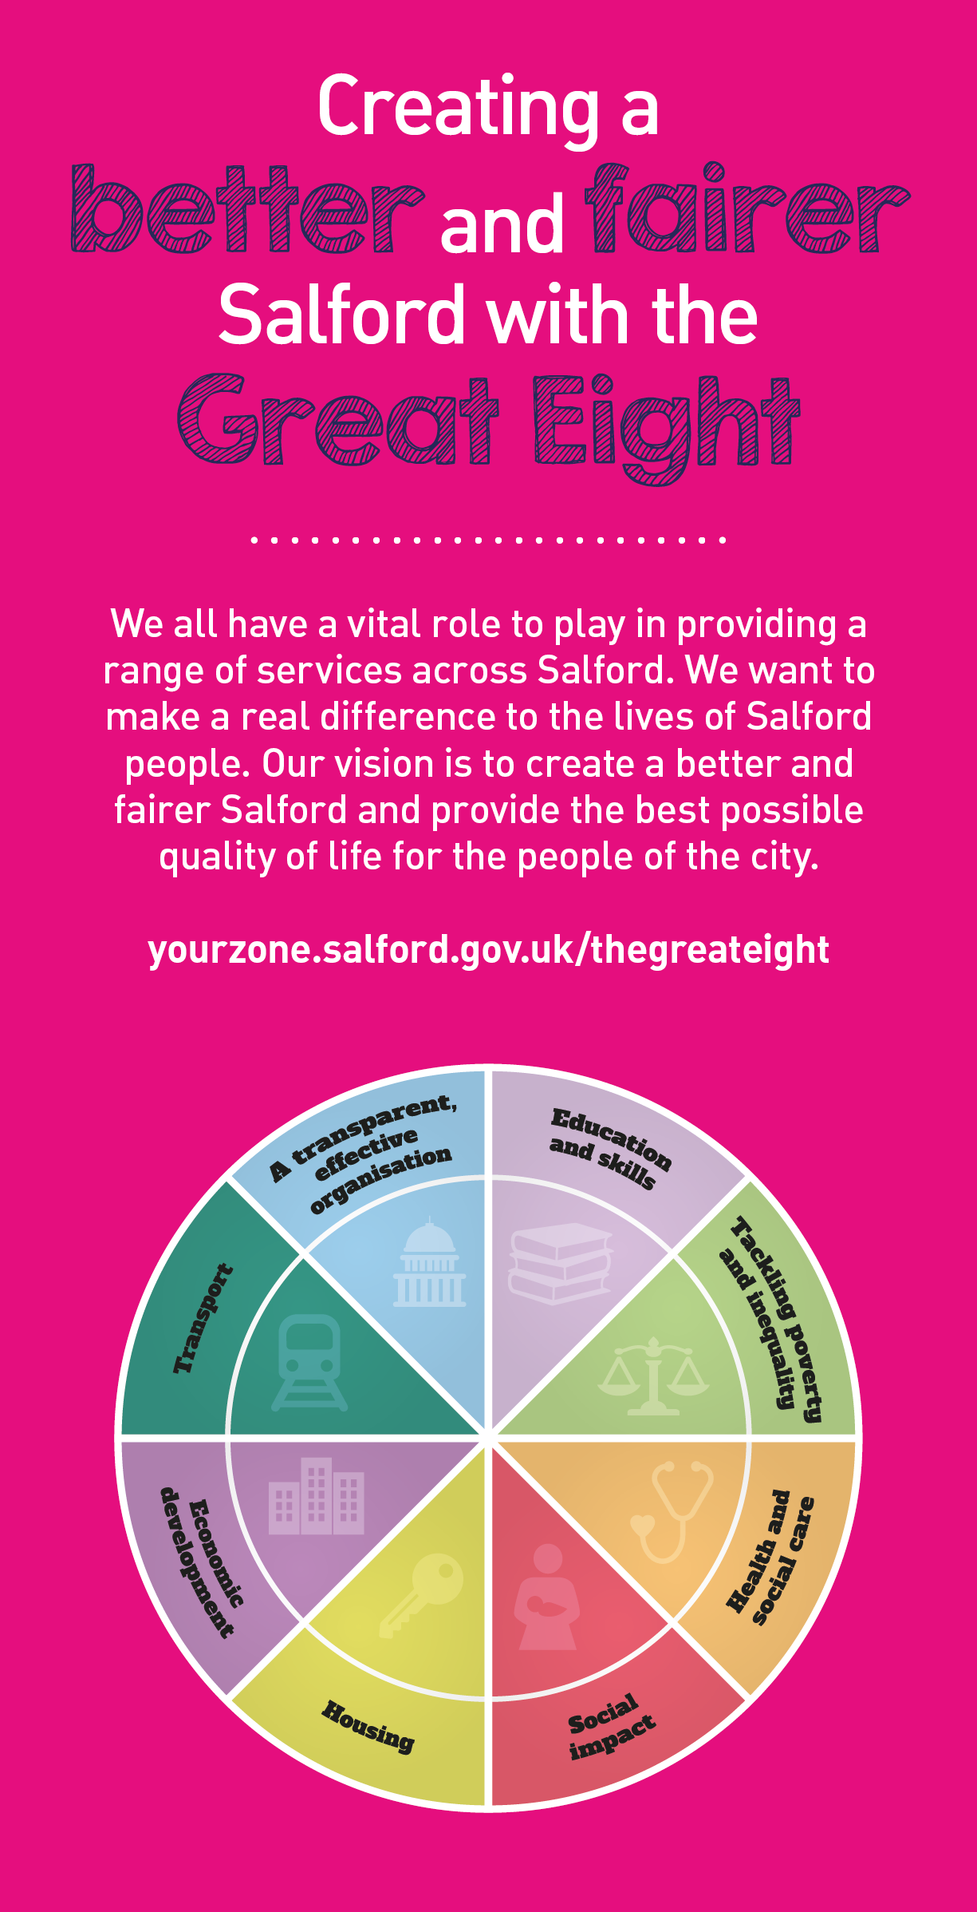
 | Key outcomes
 | - Take a leading and dynamic role in overseeing the production, maintenance and implementation of the City Council's Asset Management plan  - Take a leading and dynamic role in the City Councils Corporate Asset Management Group and the Citywide Strategic Estates Group  - To support the work of Council colleagues and public and private sector partners to deliver the City Mayor's priorities for our City from a property perspective  - Driving best value outcomes from the City Councils operational and commercial property interests maximising investment opportunities from a Property perspective working with a wide range of public and private sector partners in order to do so  - Ensure that the work of the team and all associated procedures and processes are as efficient and effective as possible  - Provide and apply strategic and practical property awareness expertise and support to the work of the team  - Build relationships with public and private sector partners across the City, promoting collaboration and joined-up thinking, co-ordinating inputs and support to maximise outcomes and outputs |  |  |  |  | - Work with public and private sector partners to develop and deliver innovative ways to secure commercial and public finance and investment funding to assist the delivery of Property based projects  - Deliver required financial and statutory targets  - Working closely with the Head of Strategic Delivery and his team in delivering the City Councils capital reciepts target and future forecast's  - Provide strategic input to property policy and programmes and to research, prepare and present strategic and high level reports and papers for consideration by the City Mayor’s Office, Members and senior management  - Manage and co-ordinate multi-disciplinary task teams in the delivery of Property projects or initiatives as required  - Provide strategic and practical project and programme leadership to major cross-cutting property thinking, projects and programmes across the City  - Oversee the management of the Strategic Asset Management team, the team's delivery programme and associated capital programme in conjunction with the Assistant Director for Property.  - Manage delivery and service planning, providing robust financial and performance management and ensuring continuous improvement and best value is delivered
 | What we need from you
 | - Proven technical skills and ability in the role with a track record of delivering required outcomes  - Professional credibility through proven relevant experience and qualification. The postholder will ideally be a Chartered Surveyor or equivalent  - Relevant and evidenced experience of leading, implementing and managing a range of transactional ,policy and strategy initiatives, programmes and/or projects to deliver improved outcomes  - Relevant and evidenced experience of inspiring a property team and leading, managing and supporting a multidisciplinary team involving both internal, cross directorate and external partners.  - Demonstrates our values and leadership behaviours  - Excellent communication skills at all levels of engagement |  |  |  |  | - Ability to think both practically and strategically "outside the box" in identifying and delivering Property based solutions and best value outcomes
Our leadership behaviours |  |  |  |  |  |  |  |  | Our values
As a values-based leader you will:  - Model the values and embed them in the way your team delivers services  - Hold people accountable for delivering the values  - Respect and care for others, treating everyone fairly, recognising the importance of ensuring equality of opportunity for all, and listening and acting on the things people say  - Be honest, taking responsibility for your actions and decisions  - Use resources that you are trusted with wisely |  | To lead and develop people you will:  - Listen to understand, not to defend  - Give people the freedom to use their initiative  - Provide opportunities for people to discuss and solve problems and issues  - Regularly provide coaching and support to others to help them achieve their objectives and potential  - Appreciate and build on people’s strengths  - Motivate, engage, encourage and inspire others in order to be the best they can be
To create a performance and development culture you will:  - Be visible, inject pace, vigour and purpose  - Expect high standards; mediocrity is not acceptable  - Take an evidence and whole system approach in making decisions  - Maximise technology and models to deliver quicker, easier, better services  - Have a digital mindset, fully utilising digital systems and solutions to deliver services differently  - Set context and challenging goals that will motivate people to take ownership, maximise performance, and develop |  | To build and communicate a vision for the future you will:  - Be optimistic and ambitious for the city and its people, helping others to understand the need to transform public services  - Build strong collaborative relationships to find creative ways to make services more sustainable and flexible  - Recognise and values the strengths of people and places, taking a strengths-based approach to make the most of opportunities  - Support people through change, in undertaking new things, and taking risks  - Take a place and whole system approach in designing, delivering and leading services  - Ensure an inclusive approach with the aim of reflecting the increasing diversity of Salford

Application guidance

We are a values based organisation so reflecting our values or a values based approach in your evidence will support your application.

The ‘Key outcomes’, ‘What we need from you’ and ‘our leadership behaviours’ sections of the Role Profile are there to give you an understanding of what we would like to see reflected in your application.

